20. Implementing Distribute Database System and Handling Data Partitioning
Create Database
USE silver1;
CREATE TABLE Student(
student_id INT PRIMARY KEY,
name VARCHAR(50),
city VARCHAR(50),
department VARCHAR(50)
);
CREATE TABLE Course(
course_id INT PRIMARY KEY,
course_name VARCHAR(50),
credits INT);
Create Tables
CREATE TABLE Course(
course_id INT PRIMARY KEY,
course_name VARCHAR(50),
credits INT);
Insert Sample Data
INSERT INTO Student VALUES
(1, 'Pratiksha', 'Mumbai', 'Computer Science'),
(2, 'Trisharna', 'Delhi', 'Mathematics'),
(3, 'Shravani', 'Mumbai', 'Physics'),
(4, 'Sejal', 'Delhi', 'Computer Science');
SELECT*FROM Student;

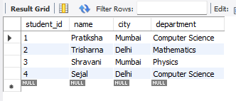

Horizontal Partioning
SELECT*FROM Student;
CREATE TABLE Student_Mumbai AS
SELECT*FROM student
WHERE city ='Mumbai';
CREATE TABLE Student_Delhi AS
SELECT*FROM student
WHERE city='Delhi';
Vertical Partioning
CREATE TABLE Student_Personal AS
SELECT student_id,name,city
FROM Student;
CREATE TABLE Student_Academic AS
SELECT student_id,department
FROM Student;
Check Storage Engines
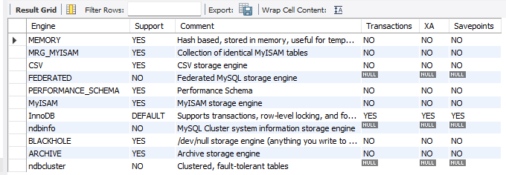

Combine horizontally partitioned tables
SELECT*FROM Student_Mumbai
UNION
SELECT*FROM Student_Delhi;

